How can I find the sums of interior & exterior angles?

Glue
Here

MCC8.G.5 Use informal arguments to establish facts about the angle sum and exterior angle of triangles.

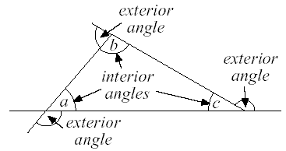
Interior=
Exterior=
Regular =
- The sum of the interior angles of a triangle is .
- The sum of the exterior angles of ALL polygons is .
Find the measure of the missing angle.

34°

x°
73°

Find the measure of the exterior angle.
x°
a°
40°
79°

The interior angles of a triangle measure 5x + 8 degrees, 9x + 2 degrees, and 15x – 4 degrees. What is the value of x? What are the measures of the angles of the triangle?

The measure of an interior angle of a triangle is 4n + 5 degrees. The measure of the corresponding exterior angle is 15n + 4 degrees. What is the value of n?

