8th Grade Physical Science
History of the Atomic Model
Directions:
- Make a four square foldable. (In Class)
- Then place the names of the four scientists on the outside in chronological order, one for each tab.
- Underneath the tab, describe their contribution to the atomic model theory, how they arrived at that idea, and a picture of their atomic model.
- Write your name and period on the back of the foldable.
- Information in your Glencoe 8th Grade Science Book starting on page 74

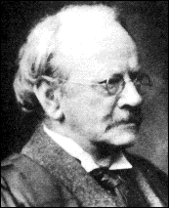  J.J. Thomson  1856-1940 | 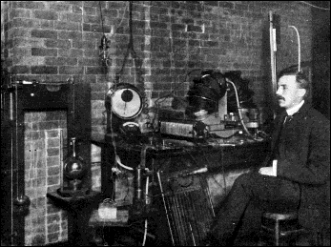  Lord Ernest Rutherford  1871-1937
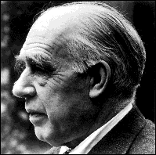  Niels Bohr  1913-1963 | 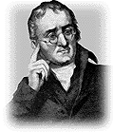  John Dalton  1776-1844
J.J. Thompson's Plum Pudding Model  The Mass of the Atom is Positively Charged with  Negative Electrons Embedded in it | Dalton's Bowling Ball Theory  Dalton Believed the Atom Was Solid, Indivisible
Rutherford's Planetary Model  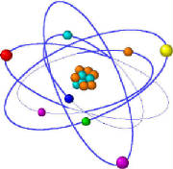  A Nucleus is Surrounded by Electrons in Orbit | Bohr's Energy Level Model (Modern)  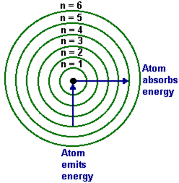  Electrons are in Energy Level Orbitals  Surrounding the Nucleus

Pictures from http://www.ploeger.myclassupdates.com/unit2/id1.html

